Online Safety Newsletter

April 2026

BBC iPlayer for Kids

Children under the age of 13 can have their own iPlayer profile, which includes content from CBBC, CBeebies and other suitable BBC programmes.

You can download the iPlayer app and then find out how to create a profile here: https://www.bbc.co.uk/iplayer/help/questions/about-the-childrens-experience/iplayer-child-experience

Going on a long journey? The BBC have also compiled a list of shows and films as well as games and quizzes to make the journey go quicker:
https://www.bbc.co.uk/cbbc/watch/best-films-games-and-quizzes-to-keep-kids-entertained-on-long-journeys


Age ratings in games

Age ratings exist to help protect your child as they show whether content is suitable for your child’s age. Make sure you check the age rating of any game your child is playing.

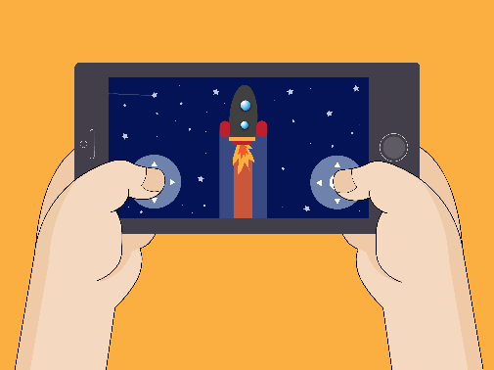
Why should I check?
Not all games will be appropriate for your child. Some may appear child friendly due to fun or cartoon style graphics but still include unsuitable content. Age ratings consider factors such as violence, frightening content, bad language and/or in app purchases.

How can I check?
Most games are rated by PEGI (Pan European Game Information), who not only state the age you should be to play the game but also provide further content descriptors to give you an indication of the type of content that your child might encounter. Apps are rated by the App store/Google Play.

How can I stop my child from accessing a game they are not old enough to play?
You can set up parental controls to restrict access to games or apps that your child is not old enough to play and set restrictions so any downloads/ purchases must be approved by you. For example:
- Nintendo – restrict software by age so if you restrict to 10+, games with that rating or above cannot be played by your child.
- Xbox / PlayStation – set an age limit so anything that exceeds that age rating must be approved.
- Apple / Google (Family Link) – restrict your child from installing apps, allowing you to review before approving all purchases.
Would you like to read this newsletter in a different language? You can use the translate tool on our web version: https://www.knowsleyclcs.org.uk/april-2026-primary/

What else do I need to do?
- Review any additional content descriptors, read reviews and check if the game includes any form of communication or in app purchases. This will help inform your decision as to whether the game is suitable for your child.
- For any game your child plays, set up appropriate parental controls.
- If you decide a game is not appropriate, explain to your child why. We know your child might feel peer pressure to play certain games, but explaining your reasoning will help them understand your decision.

Further information
- https://www.ceopeducation.co.uk/parents/articles/gaming/

How to set up parental controls on ChatGPT

Internet Matters have published an article detailing how you can link your own account to your child’s account (they must be logged in) to set parental controls on ChatGPT.

You can read the article here:
https://www.internetmatters.org/parental-controls/entertainment-search-engines/chatgpt-parental-controls/

Fake or Real? Know the Deal

Essex Police have launched a groundbreaking AI Safety Campaign in partnership with BT and EE to tackle the growing risks posed by artificial intelligence (AI) misuse and deepfake technology. This is the first time a UK police force is working directly with a global technology firm to provide practical advice to parents, guardians and young people.

AI technology offers incredible opportunities, but it also introduces serious risks when misused. Deepfake content – highly convincing, fabricated images or videos – can be used to exploit young people, sometimes without their knowledge. Artificially generated Child Sexual Abuse Material (CSAM) is one of the fastest-emerging crimes Essex Police is actively investigating.

WhatsApp update: Parent-Managed Accounts

WhatsApp have announced that they are rolling out the option of Parent-Managed accounts for those under the age of 13. The settings will include allowing you to choose who can contact your child and ensuring only you can add them to groups. Find out more here:
https://faq.whatsapp.com/894871699629864

Whilst, these features could be useful, it is important to emphasise that just because the option now exists, WhatsApp may still not be an appropriate platform for your child to be on. We often receive reports of issues, particularly with group chats on WhatsApp. Wayne Denner (online safety trainer) explains more here: https://www.waynedenner.com/whatsapp-parent-managed-accounts-what-parents-need-to-know/

The campaign is designed to help you understand:
- What deepfakes are and why they matter
- How to protect children from online harm
- What to do if an image is misused

Further information
Find out more here, including advice on how to protect your child:
https://eephonesmart.co.uk/fake-or-real
What is the Manosphere?

Have you seen the new Netflix documentary ‘Louis Theroux: Inside the Manosphere’ in which Louis Theroux interviews several ‘influencers’ that promote extreme / disturbing ideologies online. It is a shocking watch but prompts the importance of ensuring our children are protected from this content. In essence, the manosphere is against the empowerment of women and certain people promote these views and other harmful misinformation online via social media etc.

What should I do?
We need to develop critical thinking in our children and have age-appropriate conversations with them as explained in these two articles:
- https://parents.actionforchildren.org.uk/feelings-behaviour/talking-about-feelings/talk-to-your-child-gender-equality/
- https://www.brook.org.uk/blog/4-ways-to-tackle-misogyny-among-young-people/

AI and homework

AI can be a useful tool for helping children with homework both in understanding a topic and for research. However, please remember that it should not be used to complete tasks as this would constitute plagiarism.

Further information
- https://www.unwomen.org/en/articles/explainer/what-is-the-manosphere-and-why-should-we-care
Users of this guide do so at their own discretion. No liability is entered into. Current as of the date released 01.04.26. The inclusion of any links does not imply any affiliation with or endorsement of the linked websites, documents, or videos, nor are we claiming any ownership or copyright in the content of the linked materials.

